**DAILY ONLINE ACTIVITIES SUMMARY**

|  |  |  |  |  |  |  |  |  |
| --- | --- | --- | --- | --- | --- | --- | --- | --- |
| **Date:** | **21/06/2020** | | | | | **Name:** | **Katira Krishna J** | |
| **Sem & Sec** | **8th A** | | | | | **USN:** | **4AL16CS045** | |
| **Online Test Summary** | | | | | | | | |
| **Subject** | | **-** | | | | | | |
| **Max. Marks** | | **-** | | **Score** | | | **-** | |
| **Certification Course Summary** | | | | | | | | |
| **Course** | **Deep Learning Fundamentals** | | | | | | | |
| **Certificate Provider** | | | **Cognitiveclass.ai** | | **Duration** | | | **5 hours** |
| **Coding Challenges** | | | | | | | | |
| **Problem Statement: Python program to find second largest number in a list using Bubblesort** | | | | | | | | |
| **Status: Completed** | | | | | | | | |
| **Uploaded the report in Github** | | | | | **Yes** | | | |
| **If yes Repository name** | | | | | **Krishna_Katira** | | | |
| **Uploaded the report in slack** | | | | | **Yes** | | | |

Online Test Details:

No test Conducted

Certification Course Details:

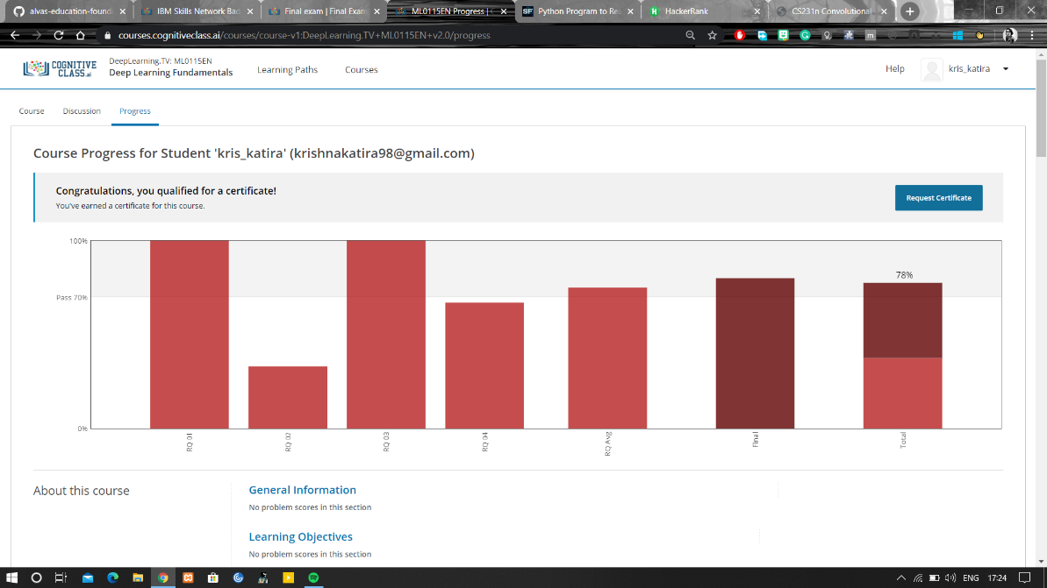

Coding Challenges Details:

**Program:**

a=[]

n=int(input("Enter number of elements:"))

for i in range(1,n+1):

b=int(input("Enter element:"))

a.append(b)

for i in range(0,len(a)):

for j in range(0,len(a)-i-1):

if(a[j]>a[j+1]):

temp=a[j]

a[j]=a[j+1]

a[j+1]=temp

print('Second largest number is:',a[n-2])